**Estate Officer (Forwarded for scrutiny to Head clerk)**

**STEP -1:**

At first login to Service plus web portal**: (**<https://tathyasathi.bangla.gov.in/>).

Login as **Estate Officer** in Service plus web portal.

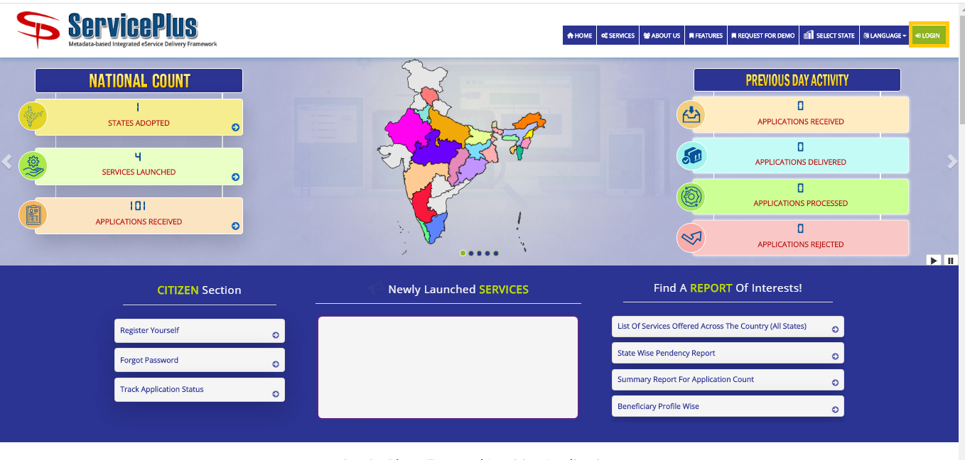

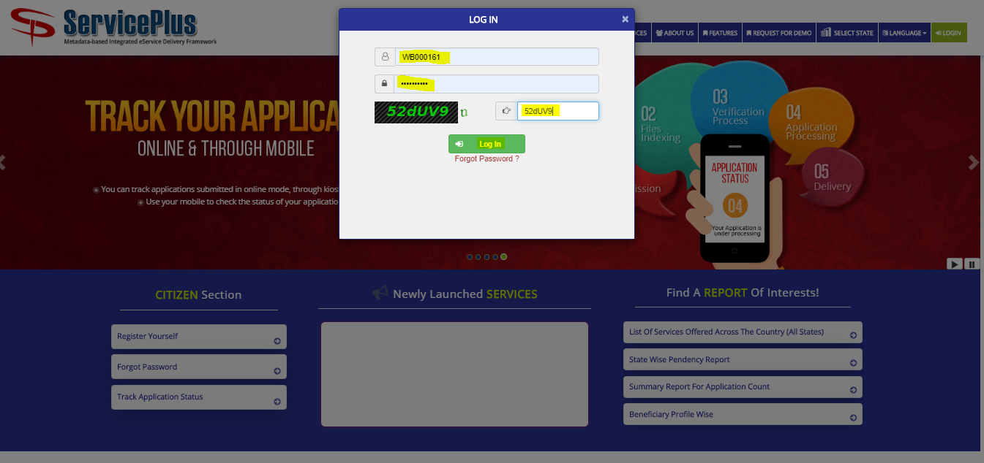

**Step 2:**

Now Go to **“Message Box”** and select **“Inbox”**.

In Inbox select the service **“Application for Surrender of Residential Flats in Bidhannagar Municipal Corporation Area”** and select the task **“Application Receipt by Estate Officer cum Joint Secretary”** and select **“Get Data”.**

Select **“Pull”/ “Take Action”** to take action.

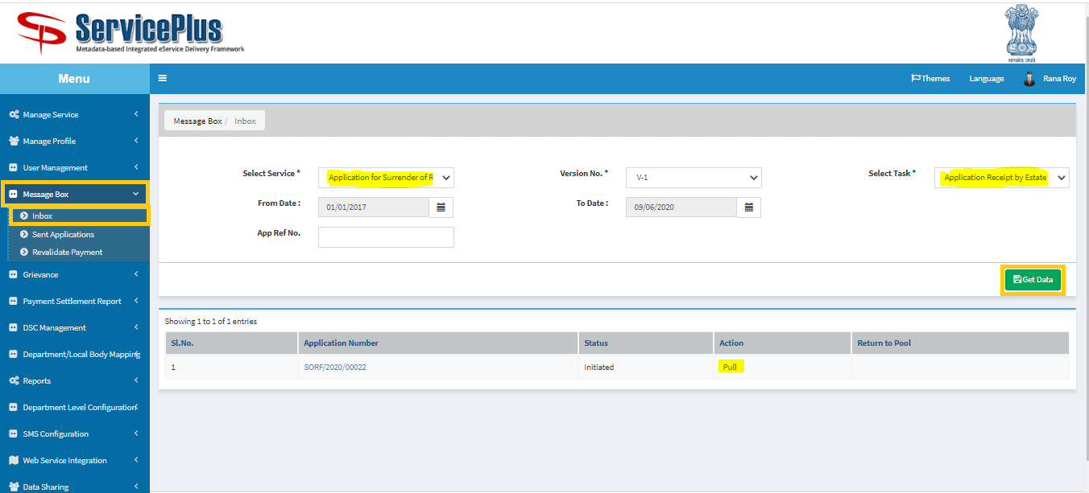

**Step 3:**

Select **“View Processing History”** to see the history of the application.

Action of the form can be taken by **Estate Officer** by taking action in two steps to **forward** and **Forward To-Supervisory Head Clerk** for Verification to “**Head Clerk”** and Give remarks and **submit**.

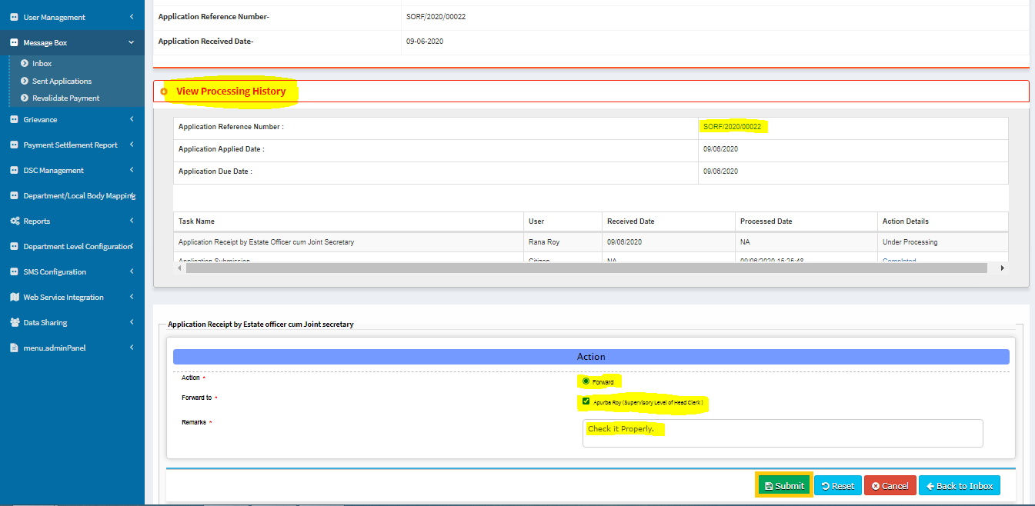

Now the application sent to head clerk successfully.

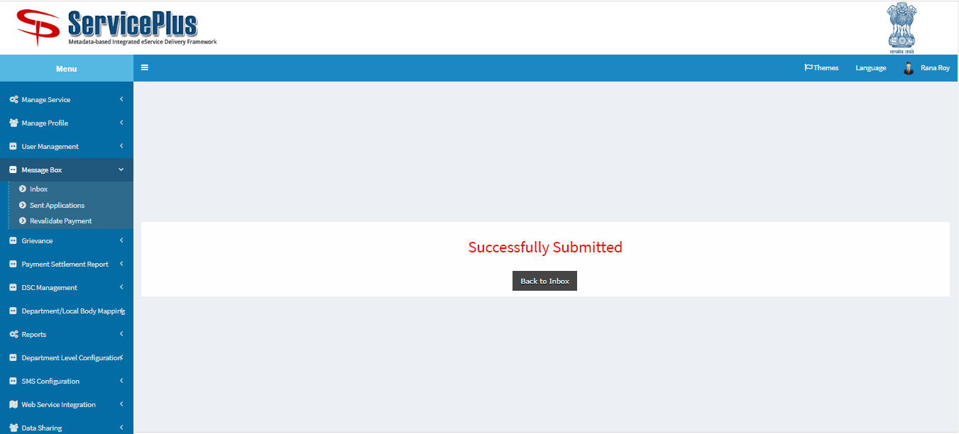

**HEAD CLERK (Scrutiny and Forwarded for shortfall or Termination Letter Generation)**

**Step 4:**

At first login to Service plus web portal**: (**<https://tathyasathi.bangla.gov.in/>).

Login as “**Head Clerk**” in Service plus web portal.

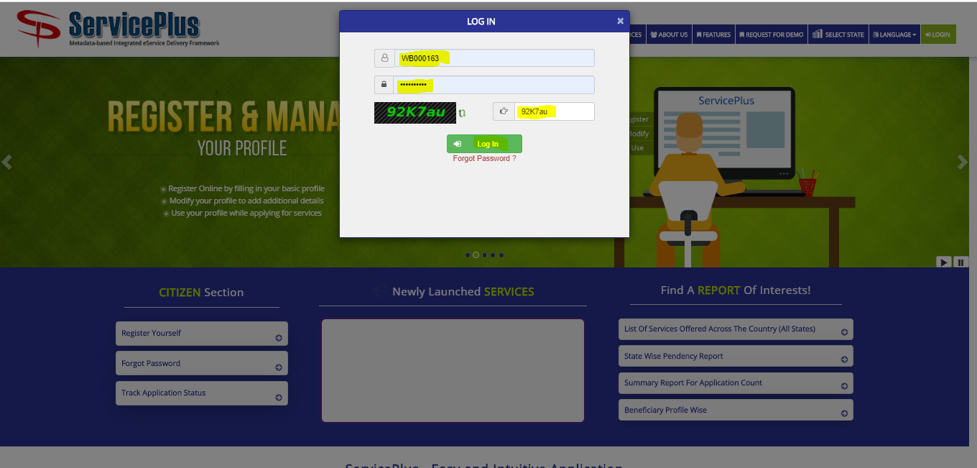

**Step 5:**

Now Go to **“Message Box”** and select **“Inbox”**.

In Inbox select the service **“Application for Surrender of Residential Flats in Bidhannagar Municipal Corporation Area”** and select the task **“Verify Application and Preparation Inspection Report by Head Clerk”** and select **“Get Data”.**

Select **“Pull”/ “Take Action”** to take action.

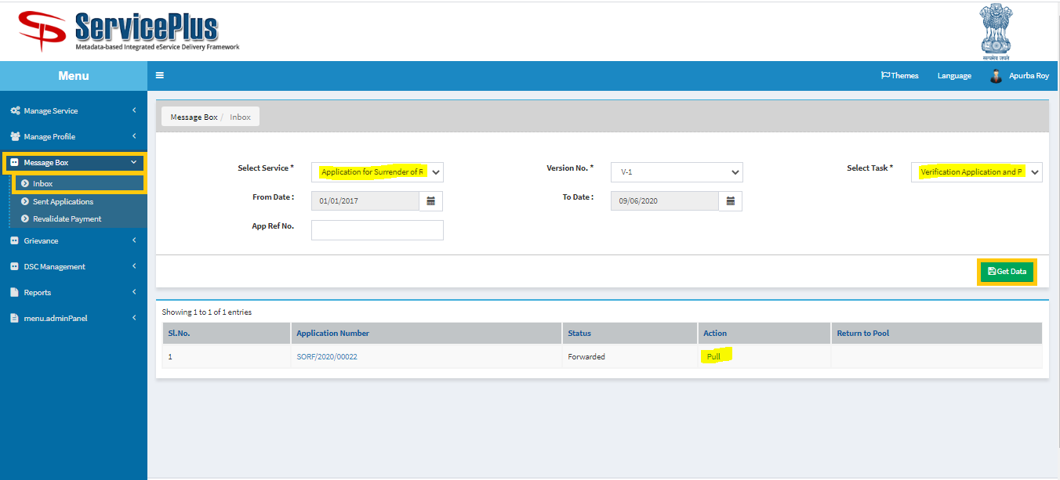

**Step 6:**

Select **“View Processing History”** to see the history of the application.

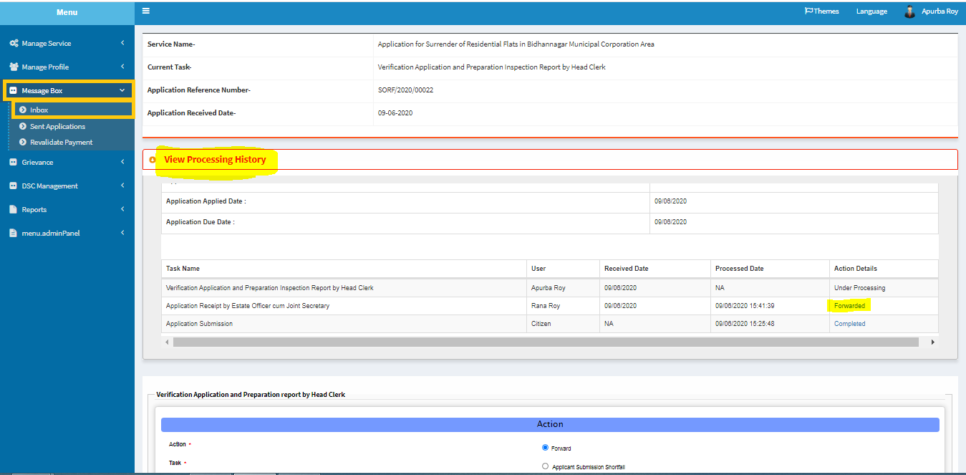

**Step 7:**

Head Clerk can process the application by forwarding to **“Generation of Termination Letter by Estate Officer” / “short fall by Applicant”.**

**For the Case of Generation Termination Letter by Estate Officer:-**

Click on “Forward” then click on “**Generation Termination Letter by Estate Officer**”. Put **Letter no** & **Deallocation Date** then Click On **Submit**.

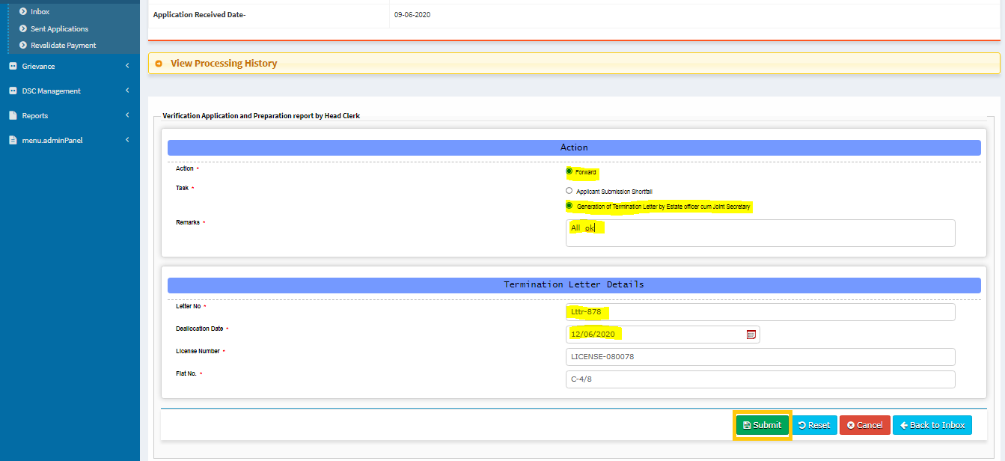

**Step 8:**

Here download file by clicking the **file** icon and **submit**.

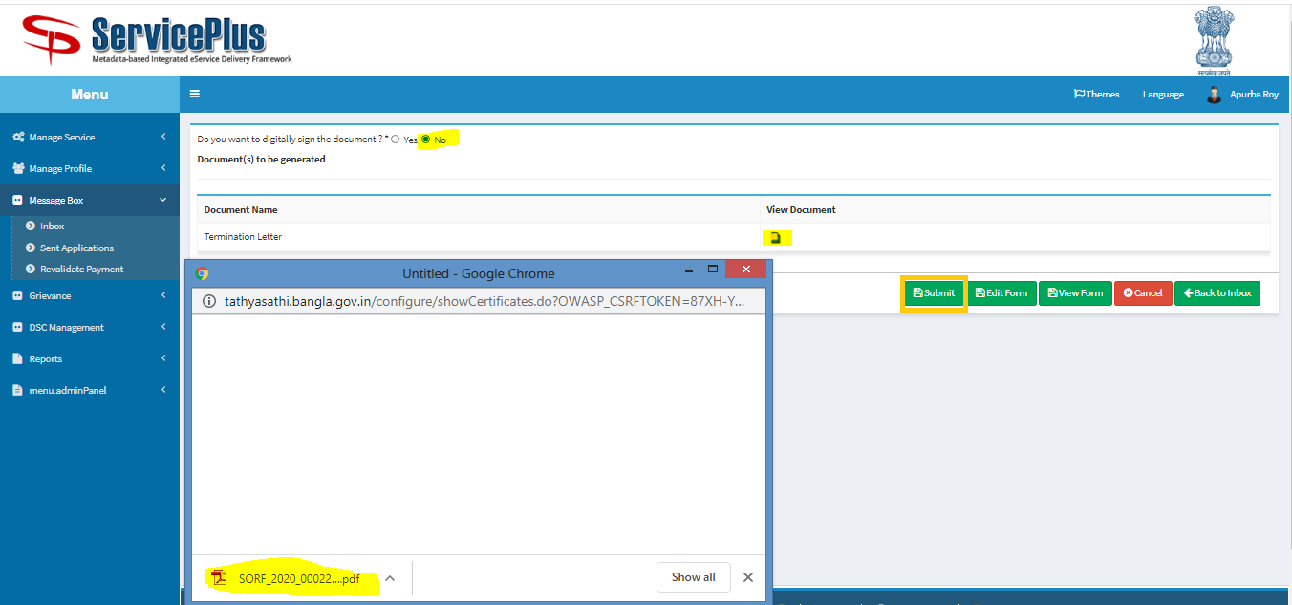

**This is the Termination Letter**

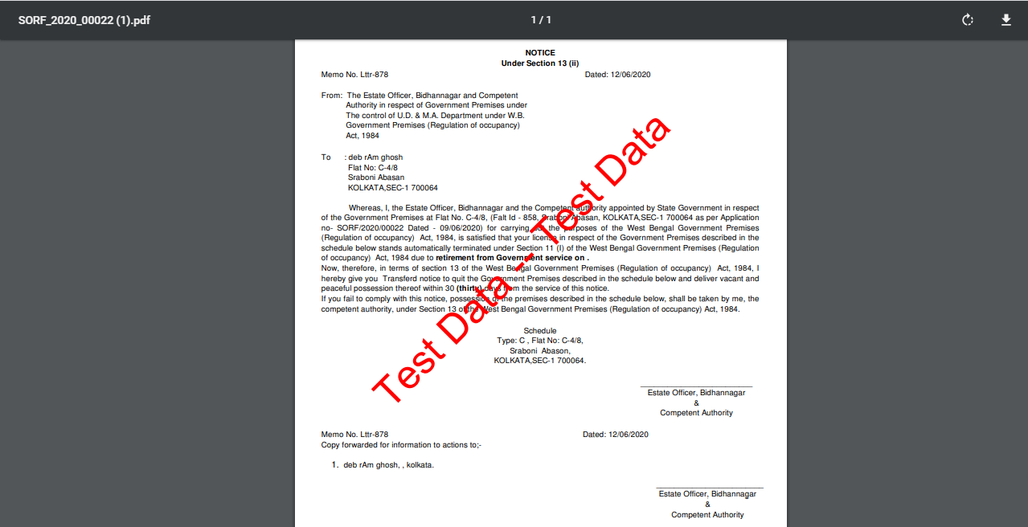

Now the application sends to Estate officer successfully.

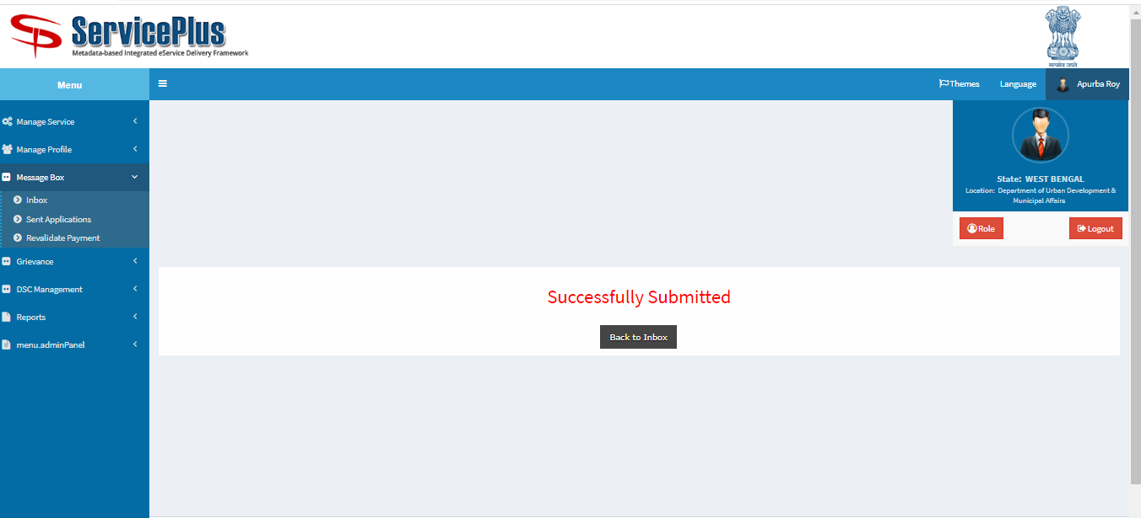

**Estate Officer (Generation of Termination Letter)**

**Step 1:**

Again Login as **“Estate Officer**” in Service plus web portal.



**Step 2:**

Select the service **“Application for Surrender of Residential Flats in Bidhannagar Municipal Corporation Area”** and select the task **“Generation of Termination Letter by Estate Officer”** and select **“Get Data”.**

Select **“Pull” / “Take Action”**.

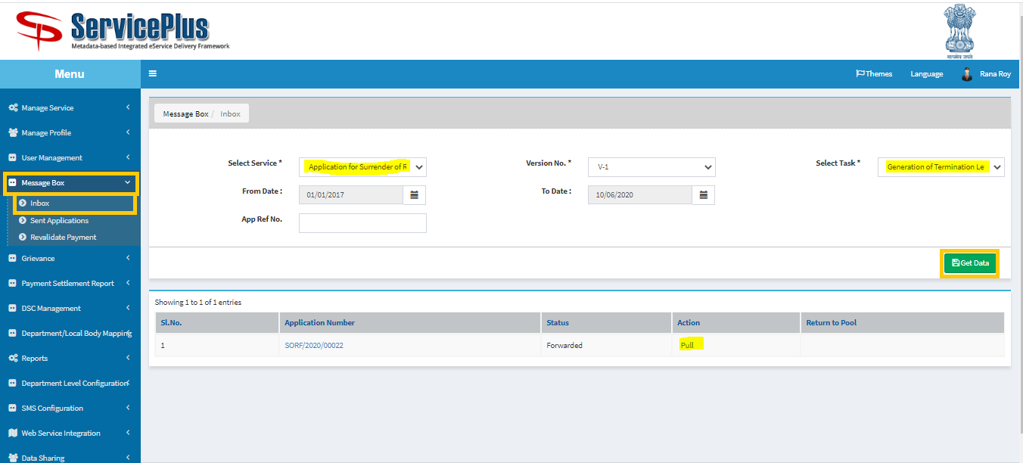

**Step 3:**

Select **“View Processing History”** to see the history of the application.

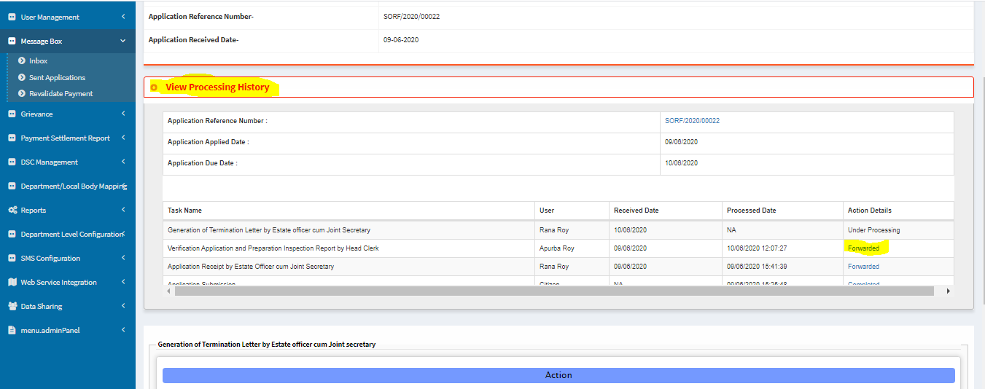

**To Generate Termination Letter**

**Step 4:**

Action of the form can be taken by **Estate Officer** by taking action to **forward** and **Vacant Existing Flat by Applicant.**

Now give **letter no** and **Deallocation Date.**

And click “**Clear Flat Data”.**

After showing success message click **“ok”** and continue

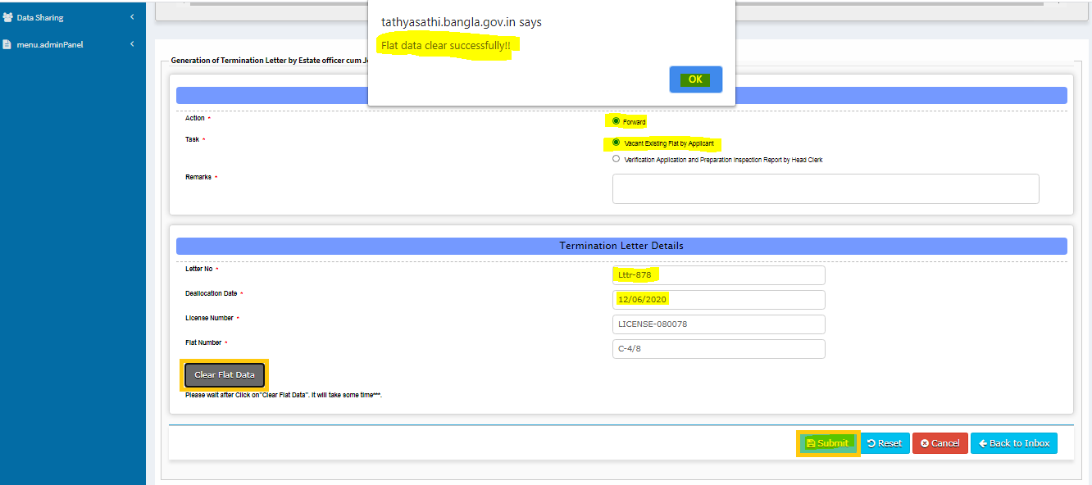

Give **Remarks** & **Submit**.

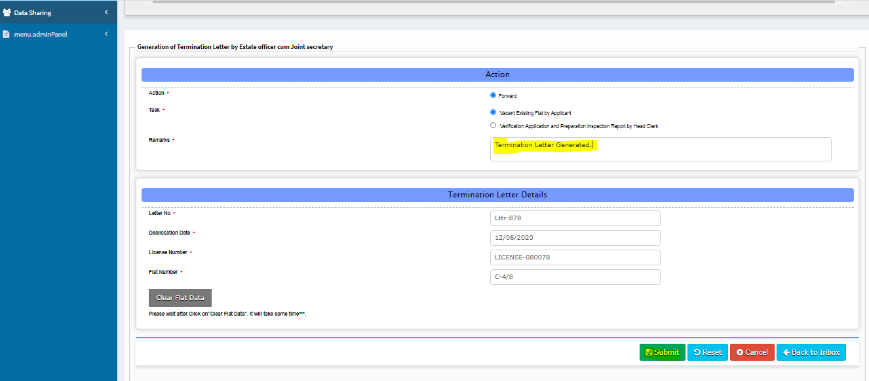

Upload The **Termination Letter** & **submit**.

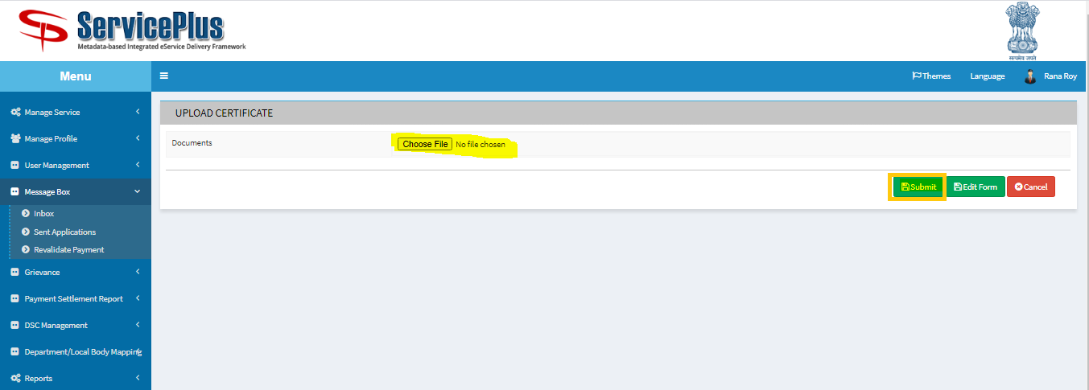

**Step 5:**

Here download file by clicking the **file** icon and **submit**.

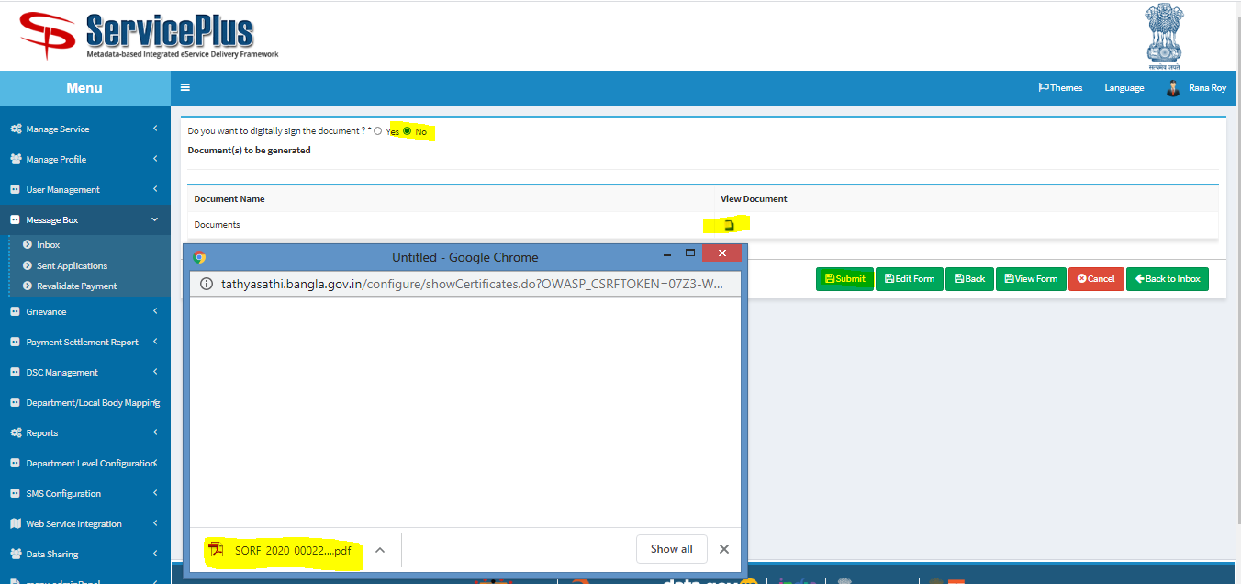

**This is the Termination Letter**

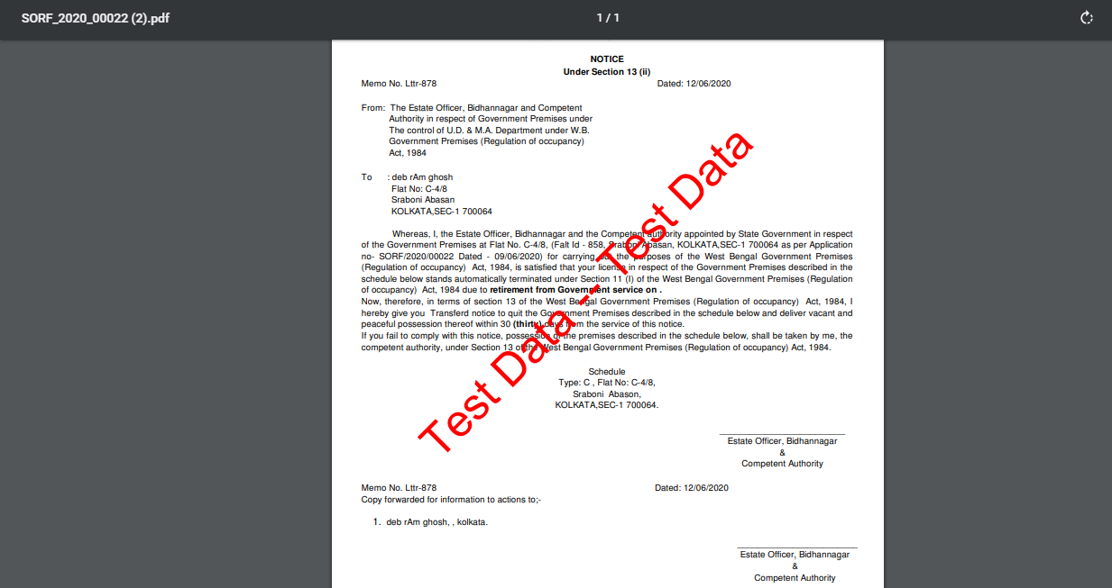

Now the **Termination Letter** sent to Applicant successfully.

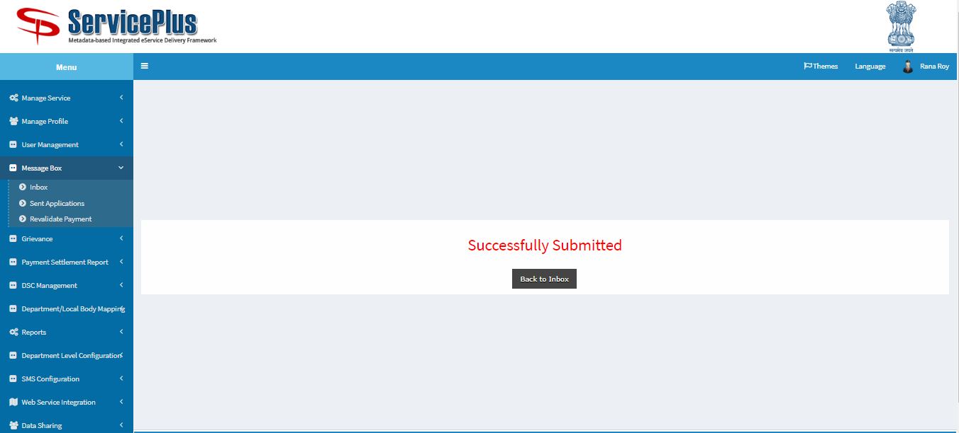

**HEAD CLERK (Take physical possession)**

**Step 1:**

Again Login as **“Head Clerk**” in Service plus web portal.



**Step 2:**

Select the service **“Application for Surrender of Residential Flats in Bidhannagar Municipal Corporation Area”** and select the task **“Physical Possession by Head Clerk”** and select **“Get Data”.**

Select **“Pull” / “Take Action”**.

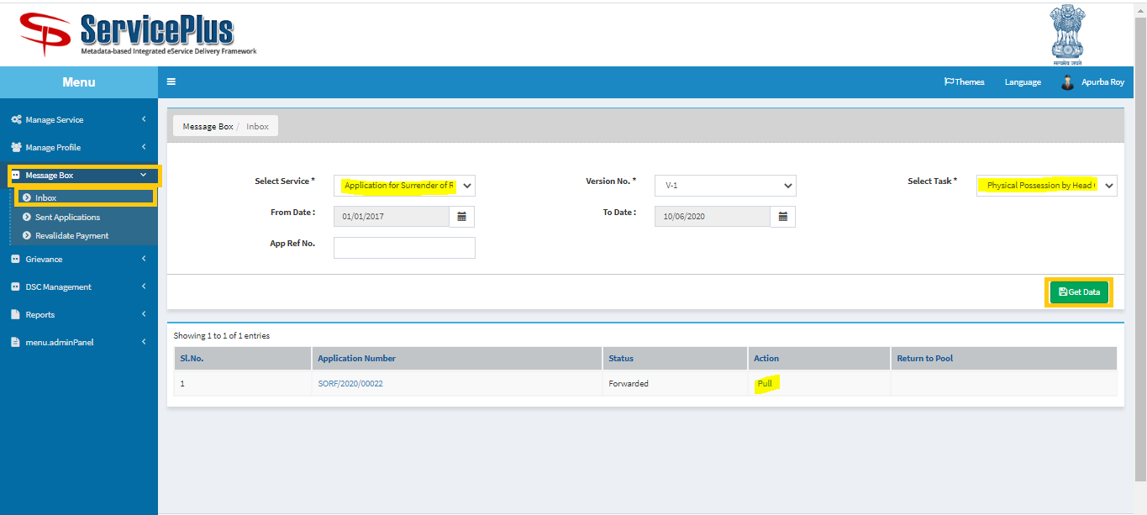

**Step 3:**

Select **“View Processing History”** to see the history of the application.

Action of the form can be taken by **Head Clerk** by taking action to **deliver.**

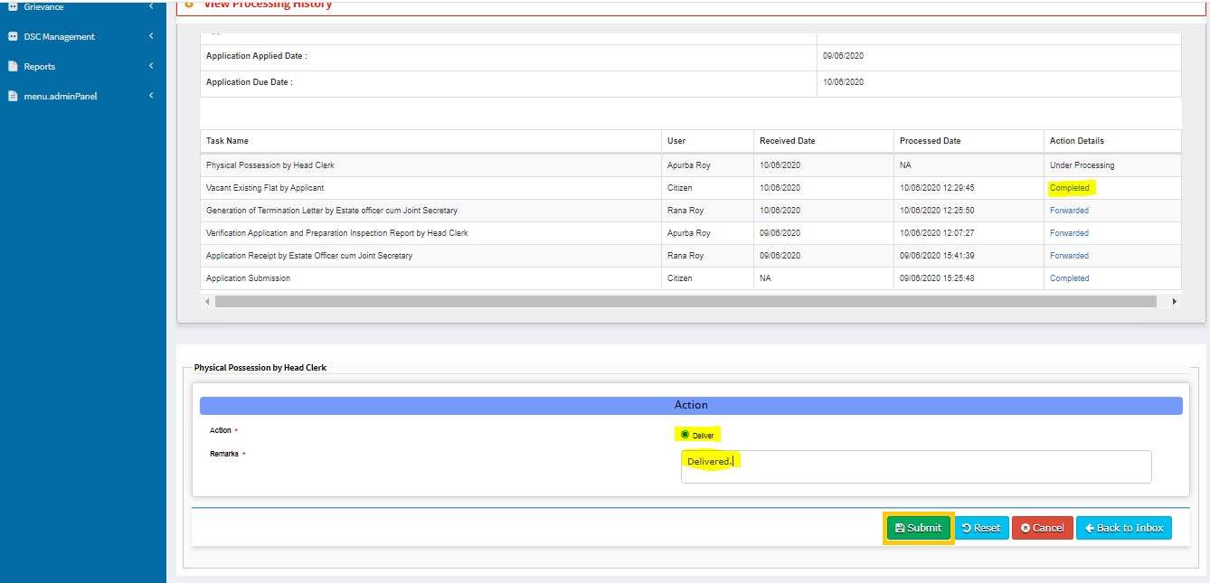

Now the Termination Letter Delivered Successfully

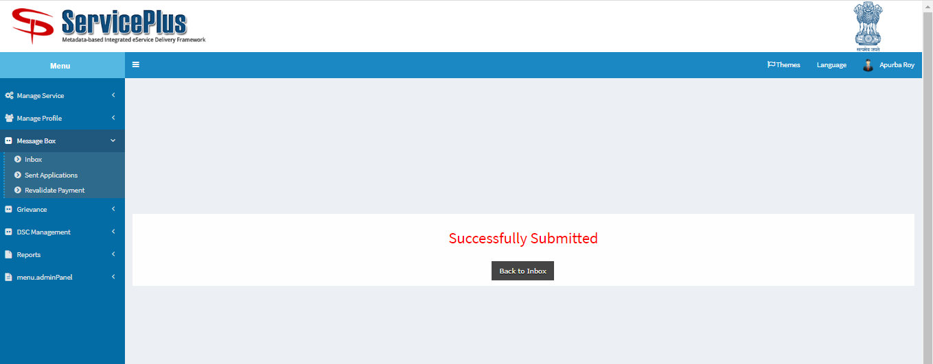

**SHORTFALL CASE**

**HEAD CLERK (Shortfall)**

**Step 1:**

Again Login as **“Head Clerk**” in Service plus web portal.



**Step 2:**

Select the service **“Application for Surrender of Residential Flats in Bidhannagar Municipal Corporation Area”** and select the task **“Verify and Preparation Inspection Generation Report by Head Clerk”** and select **“Get Data”.**

Select **“Pull” / “Take Action”**.



**Step 3:**

Select **“View Processing History”** to see the history of the application.



Action of the form can be taken by **Head Clerk** by taking action to **forward** and **Applicant Submission Shortfall** and the reason for rejection**.**

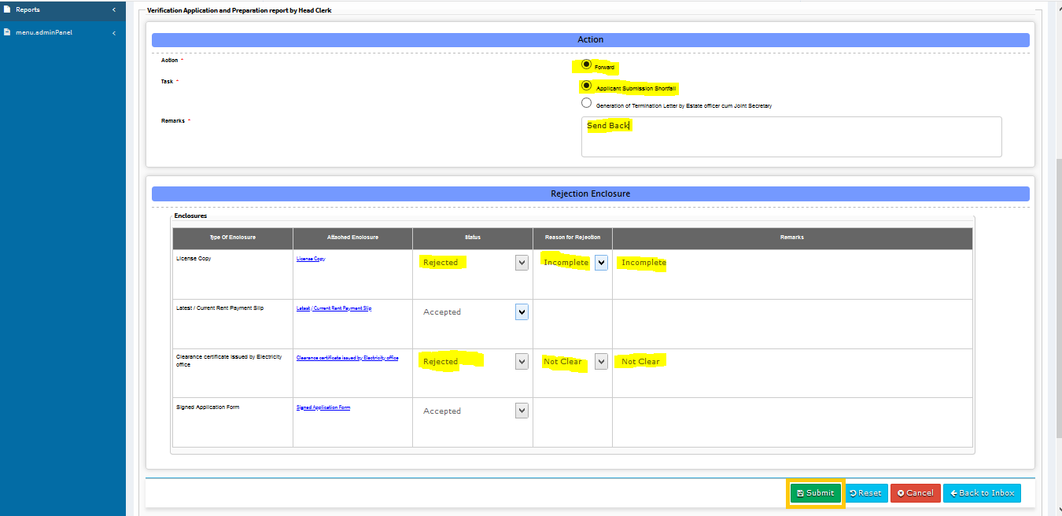

After successful submission this message will be shown.

